Growing U.S. Support for Policies to Promote Soil Carbon Sequestration
Introduction
Attitudes about climate change and farming have begun to shift dramatically in the U.S. over the last two years. Multinational corporations, federal and state government policies, mainstream farm groups and thousands of individual farmers have demonstrated serious interest in soil carbon sequestration -- both for the negative emissions it can create and the multiple benefits it offers farmers through improved soil fertility, resiliency to flooding and drought, and reduced need for fertilizer and pesticides, among others.
This document provides information that reflects the burgeoning of interest in regenerative practices from multiple ag stakeholders, including some who until now wouldn’t even acknowledge climate change.
Excerpts immediately below from articles in Politico, Financial Times and Inside Climate News indicate the scope of this sea change in the U.S.
The excerpts are followed by references to specific government policies, NGO and national farm organization projects as well as ecosystem market development relevant to soil carbon sequestration.
How a closed-door meeting shows farmers waking up on climate change (Politico, 12/ 09/2019, Excerpts)
The meeting last June in a wood-beamed barn in Newburg, Md., an hour due south of Washington, had all the makings of a secret conclave. The guest list was confidential. No press accounts were allowed. The topic was how to pivot American agriculture to help combat climate change — an issue so politically toxic that the current administration routinely shies away from promoting crucial government research on the issue.
But this meeting represented a change. It was hosted by the U.S. Farmers and Ranchers Alliance, a group made up of the heavyweights in American agriculture. It brought together three secretaries of agriculture, including the current one, Sonny Perdue, among an A-list of about 100 leaders that included the president of the American Farm Bureau Federation — a longtime, powerful foe of federal action on climate — and CEOs of major food companies, green groups and anti-hunger advocates.
...Even a year ago, such a meeting would have been improbable, if not impossible. But the long-held resistance to talking about climate change among largely conservative farmers and ranchers and the lobbying behemoths that represent them is starting to shift. The veil of secrecy attested to just how sensitive the topic remains, but over the course of the two-day gathering, the group coalesced around big ideas like the need to pay farmers to use their land to draw down carbon from the atmosphere, participants told POLITICO.
The June conclave isn’t the only sign that the agriculture industry is waking up on climate change after a truly terrible year in the farm belt, replete with historic levels of rain and disastrous flooding — a body blow that came right in the middle of a trade war.
In Nebraska, farmers are exploring ways to reorient their farms to focus on rebuilding soil and sequestering carbon...In Florida, where rising sea levels are not a hypothetical discussion, farmers and ranchers have recently launched a working group to discuss climate change and how agriculture can help. Similar groups have cropped up in North Carolina, Ohio and Missouri and more states are expected to follow. In Iowa, faith leaders have been engaging farmers on the topic, hosting discussion groups in churches and building a network of farmers who are comfortable speaking publicly about climate change.
... Food and agriculture companies are scrambling to meet consumer demands for more sustainably grown food. A slew of major food-makers including Danone, General Mills and PepsiCo have made major commitments to slash their greenhouse gas emissions and work on soil-health initiatives. Corporate giants including McDonald’s and Walmart remain committed to meeting the goals of the Paris Climate accord ... Nestlé, Mars, Unilever and Danone North America have broken from industry trade groups and formed their own alliance, in part so they can lobby Capitol Hill in support of climate policy.
...In November, a consortium made up of agribusinesses including Archer Daniels Midland, Bunge, Cargill and Tyson Foods as well as green groups like The Nature Conservancy announced it had raised $20.6 million to help stand up a new marketplace to pay farmers and ranchers for sequestering carbon and providing other environmental services. Half the money is from the Foundation for Food and Agriculture Research, which was created by Congress in the 2014 farm bill, and half matched from corporate and other contributions. The goal is to have a marketplace up and running by 2022.
...There’s also been a rush of capital into the agriculture tech space that’s spurring more interest in carbon capture. Indigo Ag, a Boston-based tech company that was recently named the No. 1 tech disruptor of 2019 by CNBC, has raised hundreds of millions of dollars in venture capital. This year, the company enrolled 12 million acres of U.S. farmland for its carbon sequestration initiative with promises to pay farmers $15 per metric ton of carbon they sink into their soil.
US agriculture secretary breaks ranks to endorse carbon pricing (Financial Times, 02/20/2020)
- A member of Donald Trump’s cabinet ... endorsed putting a price on carbon dioxide, a climate change policy favoured by many economists but shunned by the administration. Sonny Perdue, the US secretary of agriculture, on Thursday unveiled environmental goals for the farm sector that included locking more heat-trapping carbon dioxide in the soil.
- Asked about a carbon price, he said “legitimate, measurable carbon trading” could spur so-called carbon sequestration by giving farmers an incentive to innovate. “If it is a social goal and social priority there, then let’s put a price over carbon emissions,” Mr Perdue told reporters. “And I think you can really see farmers show out in their carbon sequestration efforts.”

Farm Bureau Warily Concedes on Climate, But Members Praise Trump’s Deregulation (Inside Climate News 01/ 23/2020)
- Farmers listened as the Farm Bureau's voting delegates adopted a handful of new climate-related positions—11 in all—a move that represents a concession of sorts for an organization that has long worked against climate policy.
- Among the newly adopted amendments: One supporting research and education to promote soil health, a key requirement for ensuring soil's ability to capture and store carbon, and another that calls for "unbiased science-based research on climate change."
- Farmers at the convention expressed growing optimism about the economic opportunities in taking steps to address climate change. One recent analysis found that soil and land conservation practices could bring more than $8 billion into farming communities, and that the average family farm could earn nearly $22,000 in additional income for taking carbon-storing steps on its farm.

Federal Farm Bill Policies and Legislation in the 116th Congress Addressing Soil Carbon Sequestration
Impact of 2018 Farm Bill Provisions on Soil Health (Soil Health Institute, September 2019). Overview of policies in the bill and a detailed table listing all soil-health related provisions by bill section.
A new USDA/SARE guide for farmers to boost profits through conservation (Environmental Defense Fund Blog, 07/15/ 2019) “The costs of transitioning to conservation management practices can be a barrier to adoption along with the risk entailed in change, especially in the current economic climate...A new technical bulletin from the USDA’s Sustainable Agriculture Research and Education (SARE) program Cover Crop Economics: Opportunities to Improve Your Bottom Line in Row Crops ...provides seven different management scenarios in which farmers can speed their transition to cover crops and achieve profitability more quickly — in some cases within the first year of adoption.”
The Climate Stewardship Act (S.2452 and companion bill H.R.4269), introduced by Senator Cory Booker (NJ), has been endorsed by more than 70 farmer, environmental, restoration, and forestry organizations.
The Agricultural Resiliency Act (H.R. 5861), introduced by Representative Chellie Pingree (ME), has received support from nearly 50 farming, environmental and private sector groups.

State Initiatives and Bills

- California: The Healthy Soils Initiative (HIS) is a collaborative effort that involves a coalition of state agencies and departments and is a key part of the state’s strategy to reduce GHG emissions by increasing carbon sequestration in and on natural and working lands.

- Hawaii: Established the Carbon Farming Task Force within its Office of Planning in 2017 to identify practices for improving soil health and promoting carbon sequestration through the capture and long-term storage of atmospheric carbon dioxide.
- Iowa: Established the New Ground with Innovative Cover Crop Incentive in 2017, giving farmers who plant cover crops a $5-per-acre discount on crop insurance over three years.
- Maryland: The Healthy Soils Program implements a state law requiring the state’s Department of Agriculture to provide incentives, such as research, education, technical assistance, and financial assistance, to farmers to implement practices that promote healthy soils and increase soil carbon sequestration. The state sees these incentives as part of meeting its aggressive climate goal. In the 2016/2017 fiscal year, 560,000 acres of farmland in Maryland—or about 50% of eligible land in the state—were planted in cover crops.
- New York: In April 2019, a carbon farming pilot program was allocated $400,000 as part of the fiscal year 2019–2020 state budget. The state has provided additional funding of $200,000 to the New York Soil Health (NYSH) initiative and the $4.5 million to the Climate Resilient Farming program. State Asssemblymember Didi Barrett also introduced legislation that would establish a tax credit for farmers who sequester carbon in their soil.
- For further state information, see the Bipartisan Policy Center’s publication Farm & Forest Natural Carbon Solutions Initiative and the Climate XChange webinar (5/13/2020) Natural Climate Solutions: The Role of Agriculture and Carbon Capture in the Transition (part 2, starting at 19:57).

Map of state legislative initiatives in the U.S. to promote healthy soil practices

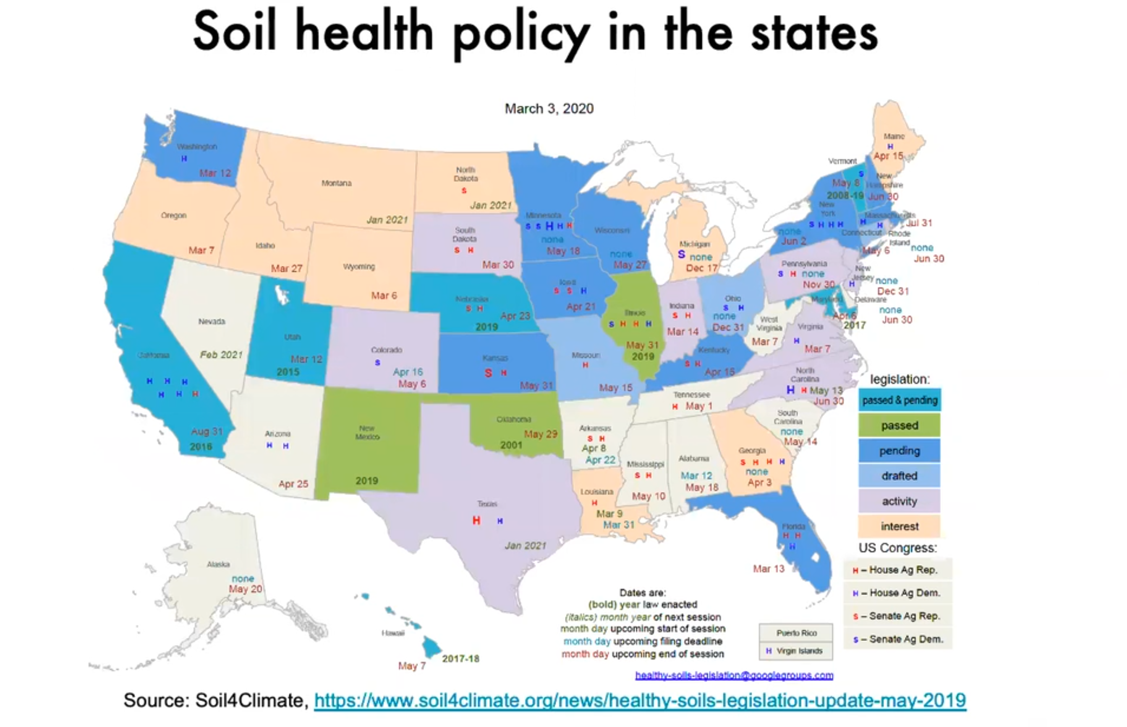

Farmers Associations

National Corn Growers Association Sustainability, including soil health and carbon sequestration, is one of the organizations current top three priorities. NCGA has created a Soil Health Partnership that works in alliance with other soil health organizations as well as government agencies and private sector companies.
With support from Foundation for Food and Agriculture, General Mills Foundation, Midwest Row Crop Collaborative, Monsanto, National Association of Wheat Growers and the Natural Resources Conservation Service.
Technical and scientific support from the Environmental Defense Fund, The Nature Conservancy and scientists from the USDA, and multiple universities.
U.S. Farmers and Ranchers Alliance “Our mission is to co-create sustainable food systems, connecting farmers, ranchers and food makers.” Partners include major ag organizations, companies such as the U.S. Farm Bureau, United Soybean Board, Bayer, Dannone, John Deere, BASF, Cortiva, and the USDA.
Its first briefing paper from 2019 “is the result of the collaboration of leading scientific experts within agriculture, business, government, academia, and conservation. We share the latest science and thought leadership on our collective opportunity to harness agricultural ecosystem services... for greenhouse gas mitigation, improved water quality and supply, and biodiversity, enabled by climate-smart agricultural practices. Further, we outline the opportunity to use new and innovative forms of capital and financing to address the impacts of climate change on our food, fuel and fiber productions systems.”

National Farmers Union

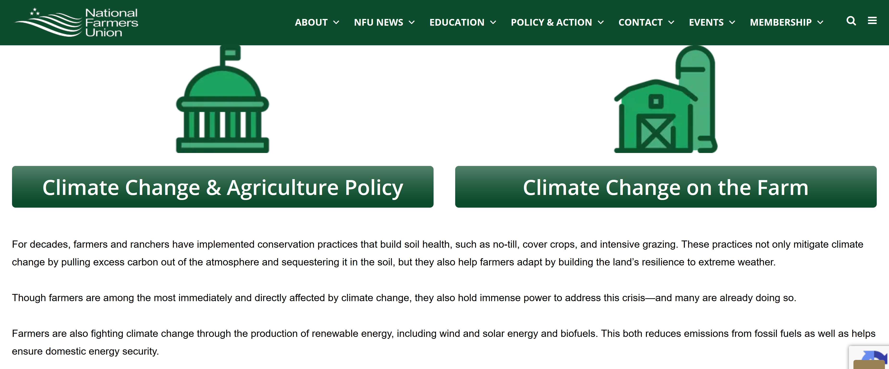

NGOs
Environmental Defense Fund: working with the USDA and Natural Capital Partners on voluntary markets for farmers and ranchers who institute soil carbon sequestration practices.
The Nature Conservancy is advancing a project on carbon markets for soil carbon sequestration.
Natural Resources Defense Council projects on food/climate/ecosystem health include regenerative farming approaches
Regeneration International Founded in June 2015, about 60 people from 21 nations, representing businesses, the farming and scientific communities, educational institutions, policymakers and NGOs to accelerate the global transition to regenerative agriculture and land management, RI today “engages with a network of more than 250 international partners and a growing number of Regeneration Alliances throughout the world.”
The organization is also a co-sponsor of Farmers and Ranchers for a Green New Deal for Agriculture, a coalition launched in September 2019, that represents 10,000 U.S. farmers & ranchers. The group is committed to working with Congress to ensure that farmers and ranchers will be a part of the stakeholders defining specific policies and programs for achieving the goals outlined in the Green New Deal Resolution. To this end, it has established a Congressional Advisory Committee whose members include Rep. Chellie Pingree (ME), Rep. Jim McGovern (MA), Rep. Jared Huffman (CA), Rep. Earl Blumenauer (OR) and Rep. Pramila Jayapal (WA).”
Soil Health Institute, whose mission is to safeguard and enhance the vitality and productivity of soil through scientific research and advancement, works with stakeholders to identify gaps in research and adoption; develop strategies, networks and funding to address those gaps; and ensure beneficial impact of those investments to agriculture, the environment and society. SHI has compiled a catalog of state level policy resources that includes listings of legislative, academic and agency resources associated with soil health.
Ecosystem Services Market Consortium was founded in 2019 with the goal of launching a fully functioning national scale ecosystem services market conceived and designed to sell both carbon and water quality credits for the agriculture sector by 2022.
Indigo Ag launched its Terraton Initiative in June 2019 with the goal of working with farmers to create a voluntary carbon market program in the U.S. and in Europe.
Hudson Carbon in Hudson, NY. Founded by Abby Rockefeller and Benjamin Banks-Dobson and supported by the Marine Biological Laboratory at Woods Hole, the project is based at the Rockefeller farms in Columbia County. Two local conservation groups, Scenic Hudson and the Columbia Land Conservancy, have also contributed to the onsite research effort, measuring soil carbon sequestration achieved through its integrated program of regenerative techniques. For more on its innovative research and goals, see the Climate XChange webinar (5/13/2020) Natural Climate Solutions: The Role of Agriculture and Carbon Capture in the Transition (part 3, starting at 33:22).

Compiled May 2020 by Eleanor Saunders, Citizens’ Climate Lobby Volunteer and Liaison to Congressman Antonio Delgado in New York’s 19th Congressional District; formerly Senior Researcher in environmental policy at the Council of State Governments/Northeast Regional Conference, New York, NY (2008-2015).

